Calculated Columns
1. Booking Duration:

DurationOfStay: =G2 - F2 i.e. CheckOutDate – CheckInDate

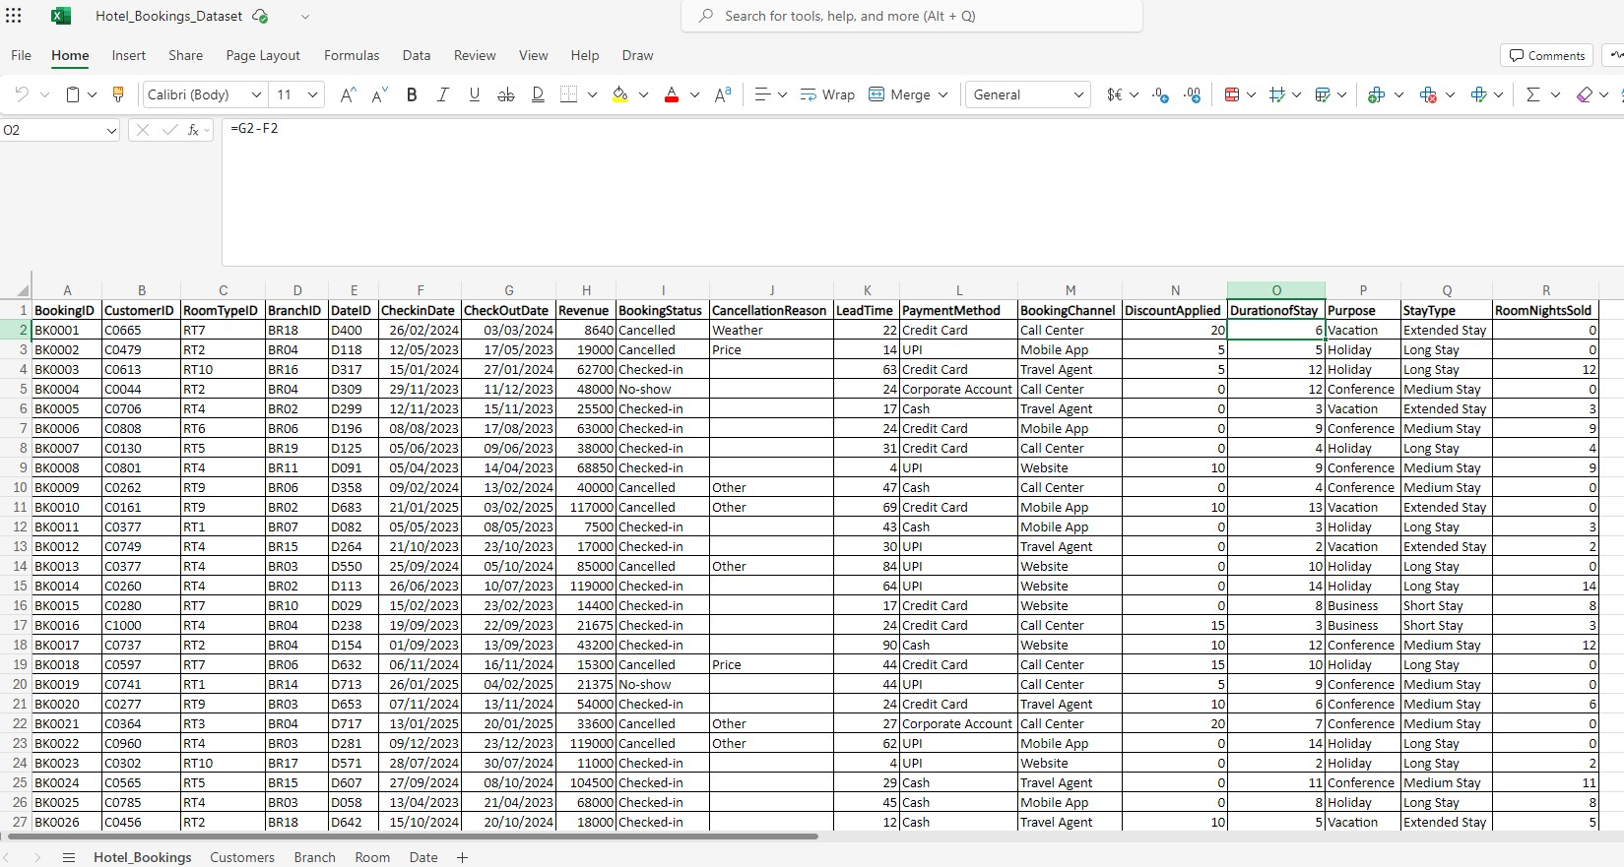

2. Room Category:

RoomCategory: =SWITCH(B2,
"Premium Sea View", "Premium",
"Suite", "Premium",
"Executive Suite", "Premium",
"Heritage Suite", "Premium",
"Studio", "Mid-range",
"Deluxe", "Mid-range",
"Family Room", "Mid-range",
"Economy", "Budget",
"Single", "Budget",
"Double", "Budget")

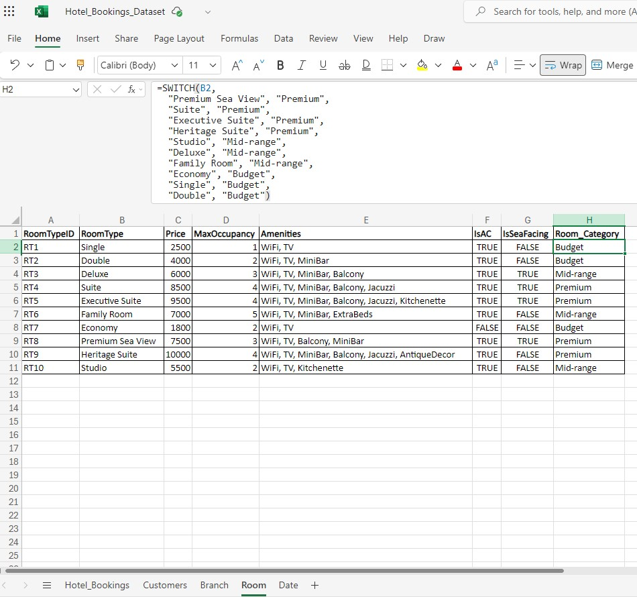
3. Stay Type

StayType: =SWITCH(P2,
"Business", "Short Stay",
"Conference", "Medium Stay",
"Holiday", "Long Stay",
"Vacation", "Extended Stay")

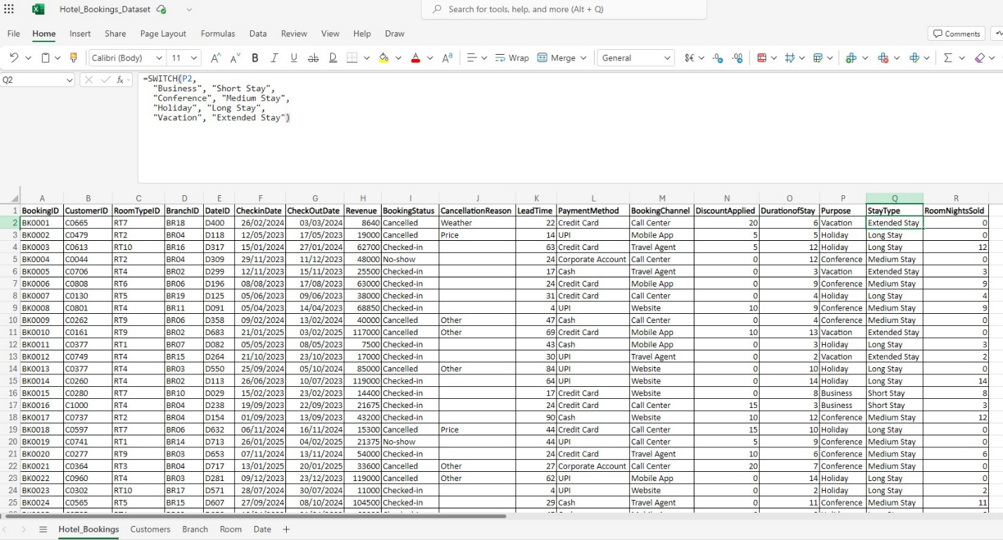

Data Modeling:
Entity-Relationship Diagram

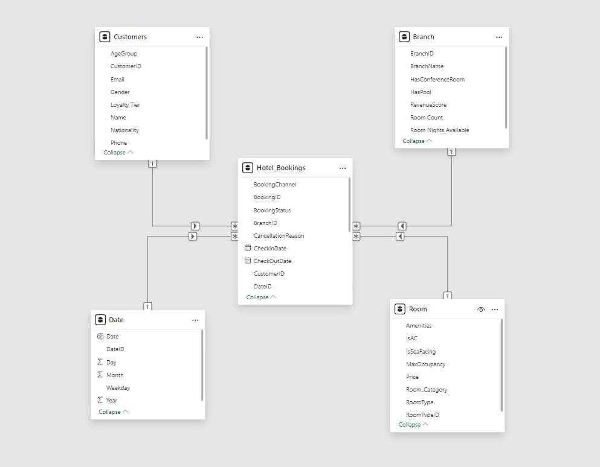

Power BI Visualization:

